# Civic Action Paired Source Analysis **Directions:** Complete the three tasks on the second page using the sources and current information from this page.

|  |  |  |
| --- | --- | --- |
| **Public Safety** | **Housing/Wealth** | **Poverty** |
| [Teen Activism vs Injustice](https://www.democratandchronicle.com/in-depth/news/2020/10/19/rochester-ny-teen-activism-on-the-rise-for-social-justice/3570783001/) | [Eviction Blockades](https://spectrumlocalnews.com/nys/rochester/housing/2020/08/07/new-housing-justice-coalition-plans-on-eviction-blockades--demands-longer-freeze) | [Income inequality in Rochester](https://www.democratandchronicle.com/story/news/politics/albany/2018/05/18/racial-income-gap-monroe-county-startling-and-among-worst-nation/622717002/) |
| [Free the People Roc](https://spectrumlocalnews.com/nys/rochester/human-interest/2020/09/17/free-the-people-roc-on-issues-important-to-their-movement)  [Instagram](https://www.instagram.com/ftp_roc/?hl=en) and [Facebook](https://www.facebook.com/ftproc) | [Pittsford town leaders split on future of housing](https://13wham.com/news/local/pittsford-town-leaders-split-on-future-of-housing) | [Union Protesting Fair Wages](https://spectrumlocalnews.com/nys/rochester/news/2020/07/20/union-representing-nursing-facility-employees-protests) |
| [Activist Ayana Mcculler](https://www.democratandchronicle.com/in-depth/news/2020/08/16/rochester-activist-ayana-mcculler-protests-and-how-get-involved/3350354001/) | [City Roots:  "Take Back the Land" Protest and Blockade](https://www.cityrootsclt.org/about/) | [RMAPI statement on killing of Daniel Prude](https://endingpovertynow.org/rmapi-statement-on-killing-of-mr-daniel-prude/) |
| [Police Accountability Board](https://13wham.com/news/local/city-of-rochester-votes-on-proposed-police-accountability-board)  [Suburbs Rally for BLM](https://www.democratandchronicle.com/story/news/2020/06/10/black-lives-matter-rochester-suburbs-pittsford-penfield-fairport-racism/5332699002/) | [Fighting Evictions at North Clinton](https://www.democratandchronicle.com/story/news/2020/01/03/rochester-tenants-fight-evictions-city-prepares-sue-landlord/2795866001/) | [The racial income gap in Monroe County is startling](https://www.democratandchronicle.com/story/news/politics/albany/2018/05/18/racial-income-gap-monroe-county-startling-and-among-worst-nation/622717002/) |

|  |  |  |
| --- | --- | --- |
| **Health** | **Environment** | **Education** |
| [Foodlink and Food Insecurity](https://www.whec.com/rochester-new-york-news/foodlink-raising-awareness-of-food-insecurity-during-hunger-action-month/5846870/%5C) | [Climate Solutions Accelerator](https://www.climategfl.org/who-we-are) | [Citizen Action: Equitable Education Funding](https://citizenactionny.org/education/) |
| [Rochester Mutual Aid Network -- responding to Coronavirus](https://rochesterbeacon.com/2020/05/15/mutual-aid-network-responds-to-coronavirus-crisis/) | [350.org -- International Movement of Ordinary People](https://350.org/about/) | [Students Protest Education Budget Cuts](https://www.nyclu.org/en/news/15-things-rochester-schools-need-do-now-after-huge-budget-cuts) |
| [African American Health Coalition](https://www.commongroundhealth.org/collaborations/african-american-health-coalition) | [Greta Thurnberg -- teen activist](https://www.theguardian.com/environment/2020/dec/10/greta-thunberg-we-are-speeding-in-the-wrong-direction-on-climate-crisis) | [School Resource Officers Eliminated from RCSD](https://www.whec.com/rochester-new-york-news/resource-officers-eliminated-from-rcsd/5762606/) |
| [Common Ground Health: Insights Report](https://www.commongroundhealth.org/insights) | [Rochester Climate Strike 2019](https://13wham.com/news/local/climate-strike-in-rochester-coincides-with-events-held-around-the-globe) | [Rochester Students Protest by Dancing for Education Reform](https://spectrumlocalnews.com/nys/rochester/human-interest/2020/08/08/students-protest-in-rochester-for-education-reform-) |

|  |  |
| --- | --- |
| **Student** |  |

**Directions:** Use the charts on the previous page and the Civic Action chart to complete the tasks below.

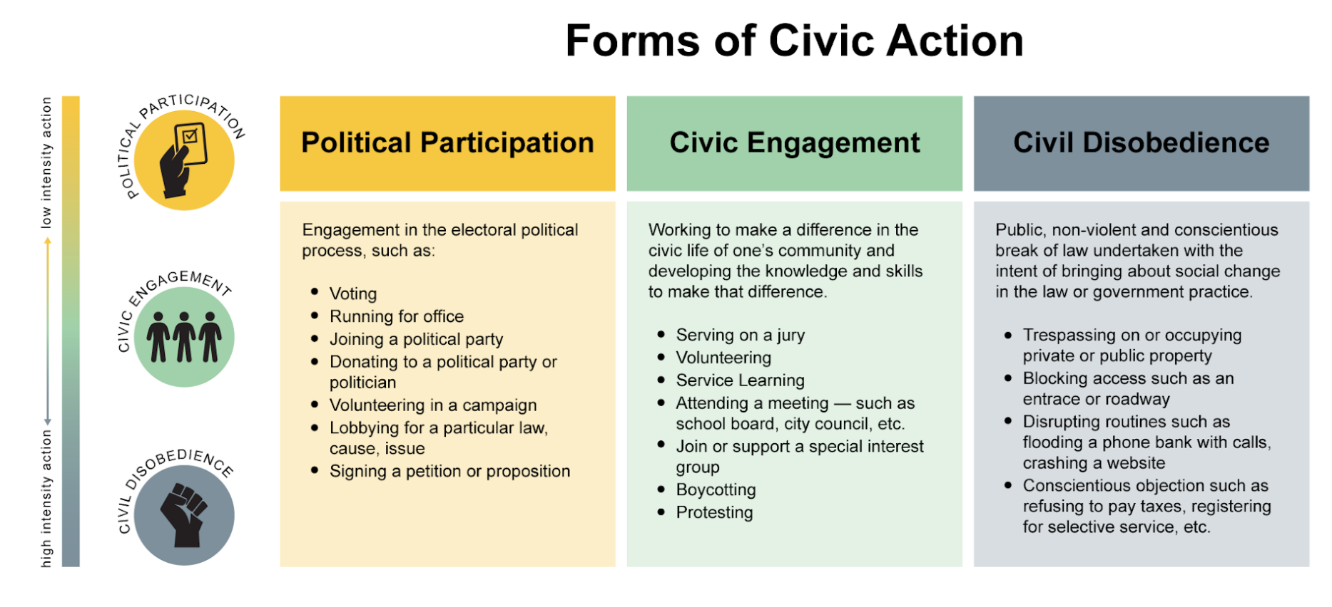

Task 1: Jigsaw Source Analysis

**✎ Identify the Jigsaw Source selected.**

|  |
| --- |
| Jigsaw 4 (School) |

**✎ Write any thoughts you have here:**

|  |
| --- |
| I thought that it was unfair to black students that they received hate and prejudice. They should’ve been accepted by others. |

**✎ Identify Civic Actions that were taken in this source.**

|  |
| --- |
| Civic engagement - protesting |

Task 2: Current Issue Analysis

**✎ Identify the Current Issue Source selected from the two tables above.**

|  |
| --- |
| Income inequality in Rochester |

**✎ Write any thoughts you have here:**

|  |
| --- |
| I found it surprising that Monroe County is ranked the 5th worst in the nation in the household income gap between white people and people of color. |

**✎ Identify Civic Actions that were taken in this source.**

|  |
| --- |
| Political participation – Workforce development |

Task 3: Paired Source Analysis

|  |  |
| --- | --- |
| **✎ Similarities:** | **✎ Differences:** |
| Both involve people of color and inequality | The Jigsaw is about schools and the current issue is about income inequality. |

**✎ Compare the civic actions in the two sources.**

|  |
| --- |
| The civic action taken in the Jigsaw was protesting, a form of civic engagement. People protested for bussing to be discontinued. Moreover, the civic action in the current issue involving income inequality was political participation, by implementing new workforce developments and skills-based training. |